**EHDA automatic spray mode control and classification**

J. P. Miranda Marques1, 2, L. P. Di Bonito2, 3, K. Glanzer2, A. Carrasco-Munoz2 and L. L. F. Agostinho2

1 Federal University of Minas Gerais, Belo Horizonte, 31270-901, Brazil

2NHL Stenden, Lectoraat Water Technology, Leeuwarden, 8917 DD, Netherlands

3University of Campania “Luigi Vanvitelli”, Department of Mathematics and Physics, Caserta, 81100, Italy

Presenting author email: joao.miranda.marques@nhlstenden.com

**Keywords**: Electrohydrodynamic Atomization (EHDA), Control System, Automation, Electrospray mode classification, Machine Learning.

Electrohydrodynamic Atomization (EHDA), also called electrospray, is a liquid atomization technique that produces micro- and nanometric charged droplets within a narrow size distribution by using high electric fields (kV/cm). According to *Cloupeau & Prunet-Foch (1994)*, electrosprays can generate droplets in different ways, which the authors named "electrospray modes". These modes may be adjusted by varying the strength of the electric field, flow rate, but also depend on liquid properties and system geometry. In their work, the authors proposed four possible EHDA modes: dripping, intermittent, cone-jet and multi-jet, which are generally distinguished visually. *Verdoold et al. (2014)* recently suggested a classification approach based on the behavior of the electric current of the electrospray process. This paper develops a closed-loop control method for EHDA devices that uses real-time, electric current-based (hence non-visual) spray mode classification.

Our electrospray system is entirely automatic, where all the peripherals, such as HV power supply and syringe pump, are controlled by a computer which executes their routines. The experimental setup can be seen in the Figure 1.

The system classifies spray mode dynamics using real-time current data and changes EHDA operating parameters such as liquid flowrate and applied voltage to achieve and maintain the chosen spray mode. The electrospray modes are validated in real time by using a high-speed camera.

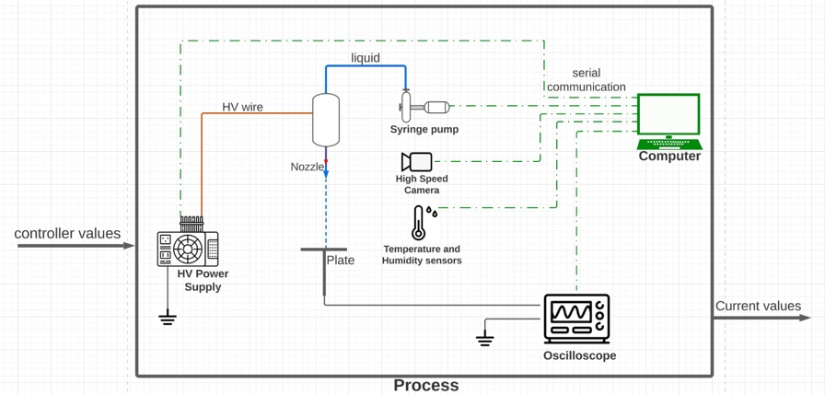

Figure 1. Experimental Setup

As compared to conventional manual approaches, the implemented control algorithm achieves higher accuracy and lower transient time. Therefore, a completely autonomous EHDA system opens the door to potential industrial applications. In addition, the use of the electric current signal will be useful to further study electrospray processes, leading to better control on droplet generation (frequency, size and charge). The incorporation of Machine Learning to improve mode categorization will be a future development.

**Acknowledgements**

This work was supported by NHL Stenden University of Applied Sciences in collaboration with the Federal University of Minas Gerais and the University of Campania “Luigi Vanvitelli”. The authors would like to thank the partners TiePie Engineering and Ynovio for their expertise and financial contribution.

**References**

Cloupeau, M., & Prunet-Foch, B. (1994). Pergamon Electrohydrodynamic spraying functioning modes: a critical review. *Journal of Aerosol Science*, 25, Issue 6.

Verdoold, S., Agostinho, L. L. F., Yurteri, C. U., & Marijnissen, J. C. M. (2014). A generic electrospray classification. *Journal of Aerosol Science*, *67*, 87–103.